**A Title is Fewest Possible Words, Accurately Describe the Content**

(Title should be Clearly Defined and Informative; using Times New Roman (TNR) size-12 pt, single spacing, bold, align center)

**Author1’s Name1, Author2’s Name2, and so on**

(Authors’ names without academic title, TNR size-10 pt, single spacing, align center)

1Institution/affiliation, address of institution/affiliation

2Institution/affiliation, address of institution/affiliation

\*Corresponding author, e-mail: xxxx@xxx.xxx

***Abstract***

*Write the abstract in English. The Abstract should be informative and completely self-explanatory. The maximum range of Abstract is 250. Abbreviations should be avoided in abstract. No literature should be cited, use TNR 10 pt and make Italic, single space, and the word ‘Abstract’ is align left. Beside that, the keyword list provides the opportunity to add keywords, used by the indexing and abstracting services, in addition to those already present in the title. The abstract must include the following separate sections:*

*Introduction, Methods, Findings, and Future remcommendation (If any).*

*You are ecouarged to write the context and purpose of the study in the introduction part. This is where you explain ‘why’ you undertook this study. Provide a clear statement of the problem. Briefly explain why you felt it was important to do research on this topic. This is your opportunity to let readers know why you chose to study this topic or problem and its relevance. Let them know what your key argument.*

*After writing introduction, you are suggested to write method. This is ‘how’ you did it. Let readers know exactly what you did to reach your results. For example, did you undertake interviews and observations? Did you carry out an experiment? What statistical tool you used to test the data?*

*Following the explainination of statistical tools and techniques, you are suggest to write findings. Here you can explain ‘what’ you found during your study, whether it answers the problem you set out to explore, and whether your hypothesis or your research assumptions was confirmed. You need to be very clear and direct and give exact explanation, rather than generalization. It’s important not to exaggerate or create an expectation that your paper won’t fulfill. In the last section you are suggested to provide future remomendation (If any).*

**Keywords:** **Maximum 5 words from paper (TNR size-10 pt).**

**Introduction**

The authors have to refer to [Journal of Social Science & Media Studies (JOSSAMS)] guidelines for format and style. [JOSSAMS] also provides a template to assist Authors in preparing manuscripts. To use this template, please just *‘Save As’* this file to your document, then copy and paste your document here.

The manuscript is written in Microsoft Word, single space, Times New Roman 10 pt, which can be downloaded at the website: https://. The main text format consists of a flat left-right columns on A4 paper. The margin text from the left, right, top, bottom 2.5 cm. Authors are suggested to present their articles in the section structure: Introduction - Methods - Results - Discussion - Conclusion - References. This article format is intended to provide a comprehensive understanding to the readers or researchers on what the article discusses and delivers.

The introduction should provide a clear background, a clear statement of the problem, explain the reason why this study is important to do*,* the relevant literature on the subject, the proposed approach, and the new value of research (novelty).

This section must present theories or concepts too (select ones in line with the focus of analysis) and/or research type to be used. Note that citation or adoption from references, i.e. international journals, should become a priority. On the other hand, secondary data, such as sources from the textbooks/e-books, national journals, scientific works (thesis or disertation) and/or internet may be adopted.

**Methods**

It should be written clearly and completely containing a clear description of analytical, and/or statistical procedures; so they can be repeated by other researchers. References of original methods/procedures must be stated and all modifications of procedures (if any) should be explained. Methods comprises brief information concerning research paradigm to be applied, approach (es), procedure(s), and type/characteristic (please select one of them) as the leading format for your research. Mention unit of analysis with comprehensive data analysis. Meanwhile, tables are presented center, as shown below and cited in the manuscript.

Table 1.The title should be brief and clear. Only the initial word is capitalized, typed above the table, and numbered using number (please follow APA style).

Table1.

*Demographic Characteristics of the Respondents*

|  |  |  |
| --- | --- | --- |
|  | Frequency | Percentage% |
| Gender | | |
| Male | 186 | 64.6 |
| Female | 100 | 34.7 |
| Age | | |
| 18 - 25 years | 152 | 52.8 |
| 24-28 | 103 | 35.8 |

Note: Footnote for statistical analysis should be written. Each abbreviation or symbols should be described in footnote (AA=.......; AB=.......)

Tables should be prepared using Microsoft Word Table function, select Insert>Table and follow the instruction. Please do not separate cells into rows and columns by using tabs and spaces. Tables should be clear and stand alone giving complete information although without text.

**Results**

This part presents results or findings. Figures or graphs can also be presented here to support your findings, and there should be no duplication of data in graphs or figures. We suggest you to mention supporting instrument(s), in forms of illustration, figures, photographs, tables, and graphs. Each instrument must be orderly numbered and given a title, followed by source from which you make the citation and if the instrument is the result from the author's analysis, figures are presented center, as shown below in the manuscript.

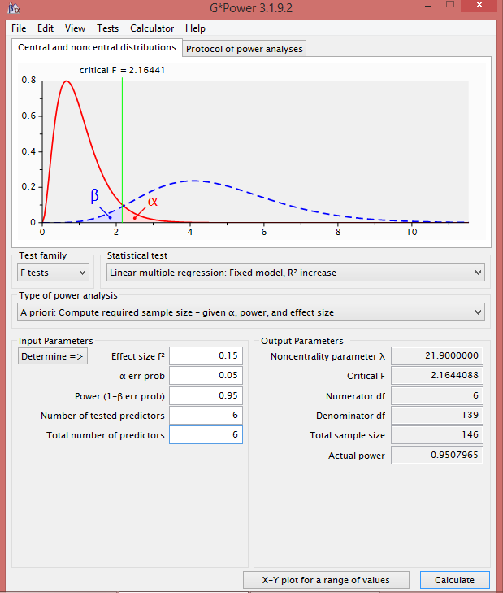

*Figure 1.* Title should be brief and clear, located under the figure or graph. Only the initial word is capitalized and numbered with number. Symbols or abbreviations, and description of figure and graph should be defined in title (±=.......; AA=.......; AB=.......) (source: ...)

Graphs using Microsoft Excel program and figures using JPEG or PDF format. Symbols and description of figure and graph should be defined in title. Figure and Graph must have good resolution. Bar charts should be made minimum in 2-dimension in the simplest shading, not a solid or block shading.

**Discussion**

This part contains analysis of the findings and reflection/discussion according to the research findings. In presenting the discussion, use a comprehensive explanation in order to elaborate the whole data found during the research. Review the information in the introduction part, evaluate their gained results, and compare it with past studies. By doing so, you can fill gap of knowledge. Furthermore, in the discussion section should be logically lead to the conclusion: are the results presented related to original question, make sure there is no repetition of results in discussion section, limitation and weakness of the study need to be explained.

**Conclusion**

Conclusion should be written briefly in single paragraph. This part presents recommendation as well as implication of the finding as a whole. Moreover, it can also be added the prospect of further studies into the next (based on results and discussion).

**References**

* APA Style references must be followed.
* Write the references in alphabetical order.
* All in text cited reference must be given in the refernces section.
* Minimum number of the priority references is 30 (references published last 10 years, from from local and international journals).
* The secondary data may include (textbooks/e-books, scientific works (thesis or disertation) and/or internet source, newpapers and other sources) .The secondary data (references also published last 10 years).
* We appiciate if you could provide references using reference management software ([Mendeley](https://www.mendeley.com/?interaction_required=true" \t "_blank" \o "Mendeley)) or Endnote with APA Styles.

**Example:**

Andersson, E. (2015). Situational political socialization: a normative approach to young people's adoption and acquisition of political preferences and skills. *Journal of Youth Studies, 1*-17. DOI: 10.1080/13676261.2015.1020926

Bell, S., & Lewis, J. P. (2015). A Survey of Civic Engagement Education in Introductory Canadian Politics Courses. *The Canadian Journal for the Scholarship of Teaching and Learning, 6*(1), 2. [DOI.org/10.5206/cjsotl-rcacea.2015.1.2](http://dx.doi.org/10.5206/cjsotl-rcacea.2015.1.2)

Chan, M., Chen, H. T., & Lee, F. L. (2017). Examining the roles of mobile and social media in political participation: A cross-national analysis of three Asian societies using a communication mediation approach. *New Media & Society, 19*(12), 2003-2021. DOI: 10.1177/1461444816653190

Dow, J. K. (2009). Gender differences in political knowledge: Distinguishing characteristics-based and returns-based differences. *Political Behavior, 31*(1), 117-136. DOI: 10.1111/j.1468-2508.2004.00161.x.

Eveland, W. P., Marton, K., & Seo, M. (2004). Moving beyond “just the facts” the influence of online news on the content and structure of public affairs knowledge. *Communication Research, 31*(1), 82-108. DOI: 10.1177/0093650203260203.

**Note: Please be sure to check for spelling and grammar before submitting your paper.**